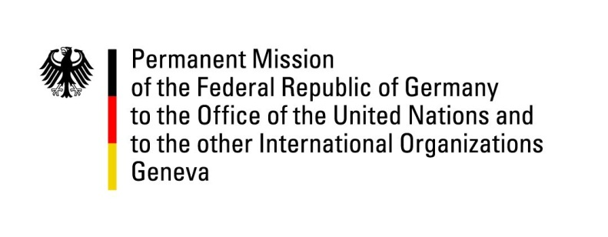

United Nations Human Rights Council

43rd Session of the UPR Working Group

Geneva, 4th of May 2023

German Recommendations

Luxembourg

Mr. President,

  - Germany welcomes the delegation of Luxembourg to the fourth UPR cycle and commends Luxembourg’s commitment to the promotion and the protection of human rights.

  - Luxembourg generally has very high human rights standards. In particular, Germany welcomes that Luxembourg adopted a national action plan for business and human rights in 2019 and Luxembourg’s numerous initiatives to promote sustainable investment. Germany also welcomes the measures Luxembourg has taken since its last UPR hearing for the modernization of prisons to improve education for minors, living conditions and health care in prisons.

  - In line with our previous recommendations and in a spirit of constructiveness, Germany recommends to:

- Continue efforts to improve conditions in prisons, especially for minors and other vulnerable groups.
- Swiftly adopt and implement the law on the protection of whistle-blowers (draft law n° 7945).
- Continue efforts to implement the national action plan on business and human rights.

We wish Luxembourg a successful UPR cycle.
  - Thank you Mr. President.

