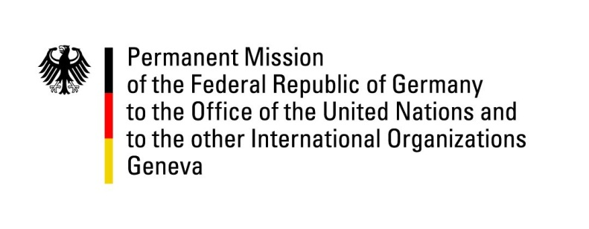

United Nations Human Rights Council

43nd Session of the UPR Working Group

Geneva, 5th of May 2023

German Recommendations and advance questions to

Barbados

Mister President,
Germany welcomes the delegation of Barbados and commends the country for the wording in the “Charter of Barbados” from November 2021, which in its Article 1, references the human dignity and rights of all Barbadians also in regards to sexual orientation, for recognizing civil unions for same-sex couples, as well as the ratification in 2022 of the ILO Violence and Harassment Convention 2019.

However, Germany remains concerned about the issue of the death penalty, recognizing a 39 year de facto moratorium in Barbados.

Germany therefore recommends to:
- Consider formalizing an official moratorium of the death penalty and taking measures in the field of future ratification of international instruments, especially the 2nd Optional Protocol to the ICPPR.
- Prohibit all corporal punishment of children, including at home, at schools, and as a sentence in courts and work towards a general understanding that corporal punishment is detrimental to the development of children.
- Combat discrimination, prejudice and violence based on sexual orientation and gender identity through legislative reform and the adoption of awareness-raising measures

Thank you, Mister President.

