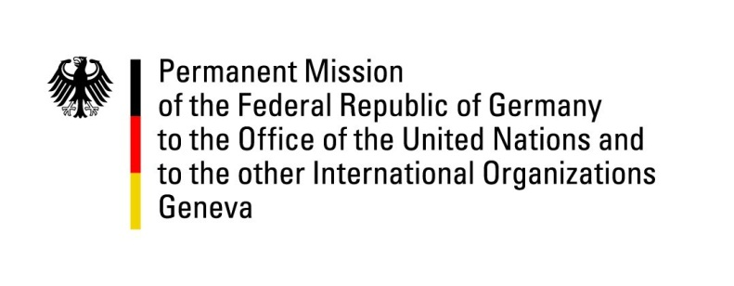

United Nations Human Rights Council

43rd Session of the UPR Working Group

Geneva, 8th of May 2023

German Recommendations and advance questions to

United Arab Emirates

  - Mister President,

  - Germany welcomes the delegation of the UAE and commends the UAE for improving the legal and institutional framework for human rights, notably by revising domestic labour law, and would like to encourage more visibility for the newly established National Human Rights Institution.
  - In line with our previous recommendations and in a spirit of constructiveness, Germany recommends the UAE to:

- Finalize the work on a National Human Rights Action Plan soon.

- Ratify the International Protocol on Civil and Political Rights, the ICESCR and other core human rights treaties to ensure a more effective protection of human rights.

- Ratify the Second Optional Protocol to the ICCPR to fully abolish the Death Penalty.

- Further reduce the necessity for foreign and expat workers to be sponsored by an employer and swiftly introduce a minimum wage as stipulated in the labour law.

- Accede to and fully implement the 1954 Convention relating to the Status of Stateless Persons and the 1961 Convention on the Reduction of Statelessness.

  - Thank you Mr. President.
GERMAN ADVANCE QUESTIONS TO UAE:

- What does the Government of the UAE do to improve the housing conditions of migrant workers, and which conclusions does it draw from experiences made during the Covid pandemic?

- Are there any plans to increasingly naturalize the so-called Bidoon and their descendants?

- On which legal basis do the UAE prevent independent observers or even close family members to watch proceedings at the country’s criminal courts, although access is granted by the UAE Criminal Procedure Law?

- Which steps will the UAE Government take to increase confidence in its criminal justice system and the security forces so that foreign female victims of human trafficking, sexual abuse and harassment do not primarily need to seek protection of their respective embassies any more?

