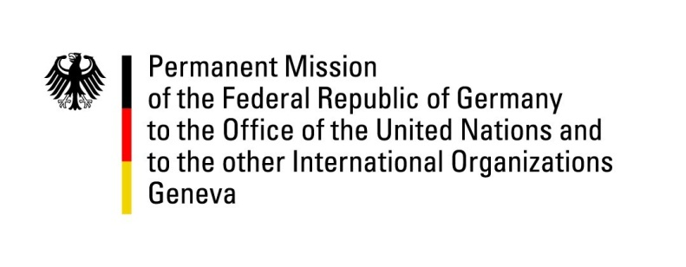

United Nations Human Rights Council

43rd Session of the UPR Working Group

Geneva, 9th May 2023

German recommendations and advance questions to

Israel

Mister President,
Germany welcomes the delegation of Israel and commends Israel for its presentation today.
Since its foundation 75 years ago, Israel is the only functioning and stable democracy in the Middle East – in the face of unique security threats in the region. Germany wishes to reiterate its fundamental commitment to Israel’s security and the close friendship between our countries. Our friendship is deeply rooted in shared values, including the rule of law and the protection of human rights. The current debate and protests on domestic issues within Israel clearly demonstrate that freedom of opinion and expression and of assembly are fully guaranteed by Israel. Israel is leading by example on LGBTQI rights.

However, Germany remains concerned about certain developments regarding the human rights situation in the country as well as in the occupied Territories, in particular the rise in violence by Israeli settlers against Palestinian civilians, as witnessed during the horrendous events in Huwara, the protection of women and children from violence and the treatment of detained persons. Moreover, Germany rejects the death penalty under all circumstances and therefore observes latest developments in Israel in this regard with great concern.

Germany therefore recommends to:

- improve security in Arab-Israeli communities inter alia through increased police presence in communities concerned.
- protect women and children, especially Arab-Israeli, from violence.
- abolish administrative detention and stop isolation detention. While still applied, improve conditions of minors in detention – including scrutiny of the relevant legal framework.
- immediately halt any kind of further initiatives to introduce the death penalty into the penal code.
- effectively protect civilians in the occupied Palestinian territories from violence by Israeli settlers and conduct criminal investigations of such incidents (in particular the incident in Huwara).

Thank you, Mister President.

