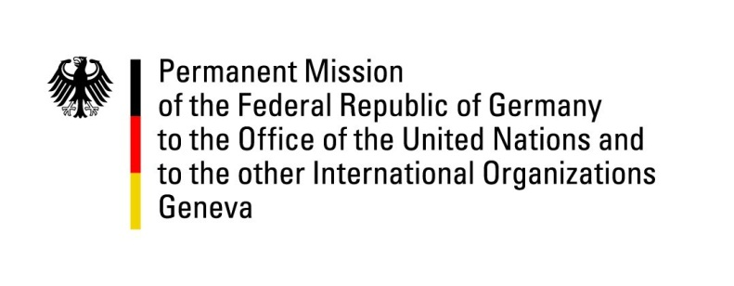

United Nations Human Rights Council

43rd Session of the UPR Working Group

Geneva, May 2023

German Statement

Liechtenstein

Germany welcomes the delegation of Liechtenstein. We commend Liechtenstein’s commitment to human rights at home an abroad.
We particularly support the ratification of the Istanbul Convention, as well as the signing the CRPD as important steps to their full implementation.
Liechtenstein’s commitment in the fight against impunity is crucial and almost unparalleled. The Finance against Slavery and Trafficking Initiative as well as the most recent Veto Initiative were milestones.

However, while Liechtenstein has reached a high stand of human rights protection, there is always room for improvement:
Germany recommends
- Taking legal measures to extend marriage to same-sex couples

- adjusting the government's proposal for paid parental leave to ensure that low-income earners can also enjoy the benefits

- taking measures to statistically identify those affected by and threatened with material poverty and expanding low-threshold access to support and counselling centres, especially for children and the elderly, and creating support services that go beyond material provision.

German Advance question:
What reservations does Liechtenstein have regarding the ratification of the Migrant Workers Convention as well as the Additional Protocol to the International Covenant on Economic, Social and Cultural Rights?

