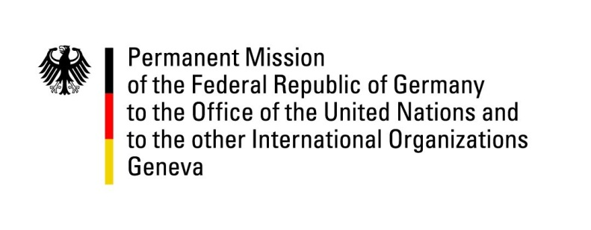

United Nations Human Rights Council

43nd Session of the UPR Working Group

Geneva, May 3rd, 2023

German Recommendations and Advance Questions to

The Commonwealth of The Bahamas

Mister President,
Germany welcomes the delegation of The Commonwealth of The Bahamas.

Germany commends The Bahamas for their strong culture of democracy and respect for Human Rights. With their 2019-2021 membership of the Human Rights Council, The Bahamas have made an important contribution to furthering the interests of the Small Islands Developing States and to improve our understanding of the interrelatedness between Climate Change and Human Rights.

However, Germany remains concerned about the increase in cases of sexual and gender-based violence, as well as the difficult situation of migrants and stateless persons in The Bahamas.

Germany therefore recommends to:
- Takes adequate measures to combat sexual and gender-based violence, including through amending relevant legal frameworks to outlaw spousal rape.
- Extend legislation on non-discrimination to include discrimination based on sexual orientation and gender identity.
- Codify the longstanding practice of non-implementation of the death penalty by ratifying the Second Optional Protocol to the International Covenant on Civil and Political Rights.
- Adjust legislation to combat statelessness, including by granting women equal rights to pass on the Bahamian citizenship.

Thank you, Mister President.

GERMAN ADVANCE QUESTIONS TO THE BAHAMAS:
- What steps is The Commonwealth of The Bahamas taking to improve prison conditions and fight overcrowding of prison and detention facilities?
- When will The Commonwealth of The Bahamas introduce the long-planned office of an ombudsperson for human rights?
- How does The Commonwealth of The Bahamas plan to tackle the increase in cases of sexual and gender-based violence?

