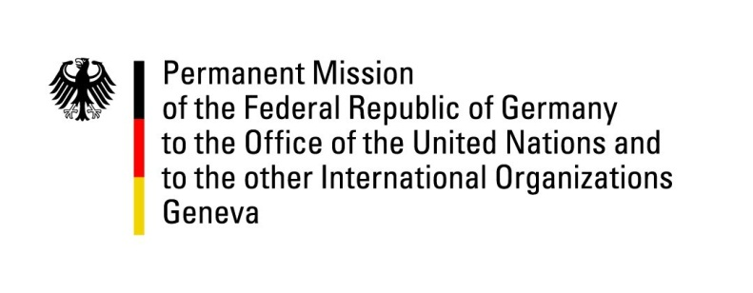

United Nations Human Rights Council

43nd Session of the UPR Working Group

Geneva, 2nd of May 2023

German Recommendations and advance questions to

Romania

Mister Vice - President,
Germany welcomes the delegation of Romania to the UPR. We commend Romania for its adoption of the “National strategy for the inclusion of Romanian citizens belonging to Roma minorities (2022-2027)”.
However, Germany remains concerned about sexual and gender-based violence in Romania.

Germany therefore recommends to:
- Adopt as quickly as possible the “National Strategy for Promoting Equality of Opportunity and Equal Treatment between Women and Men and for Preventing and Combating Domestic Violence (2021-2027)”.
- Collect and publish disaggregated data at regular intervals on cases of all forms of violence and discrimination covered by the scope of the Istanbul Convention.
- Take necessary steps to guarantee the sexual health and rights of women and girls, including economically disadvantaged and refugees, for example by including on-request abortions in the list of procedures from the National House of Insurance.
- Improve awareness of human rights within the daily work of public institutions by providing systematic training and enhancing cooperation with vulnerable groups.

Thank you, Mister Vice-President.

