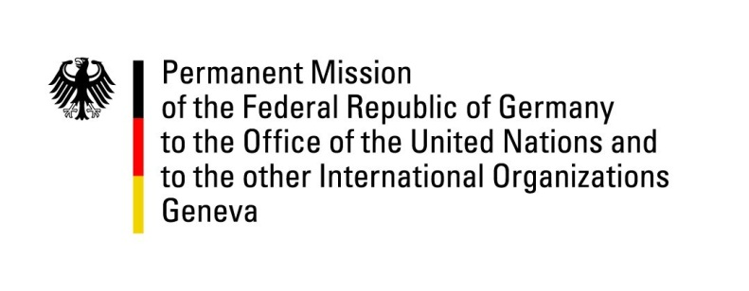

United Nations Human Rights Council

43nd Session of the UPR Working Group

Geneva, 1st of May 2023

German Recommendations and advance questions to

Tonga

Mister President,
Germany welcomes the delegation of the Kingdom of Tonga.

Germany commends Tonga for its long-standing moratorium on executions and for creating favorable conditions for civil society organizations to pursue their work.

However, Germany remains concerned that Tonga has not ratified a number of core human rights conventions, for example about high levels of domestic and sexual violence as well as discrimination against women and girls and about the continuing criminalization of same-sex relationships.

Germany therefore recommends Tonga to:
- Ratify the International Protocol on Civil and Political Rights, the International Covenant on Economic, Social and Cultural Rights and other core human rights treaties, such as the Convention on the Elimination of all Forms of Discrimination Against Women or the Convention against Torture, to ensure more effective protection of human rights.
- Increase protections against gender-based violence against women and girls.
- Decriminalize consensual same-sex relations between adults.
- Ratify the Second Optional Protocol to the International Covenant on Civil and Political Rights to fully abolish the Death Penalty.

Thank you, Mister President.
GERMAN ADVANCE QUESTIONS TO TONGA:
- When does the government of Tonga plan to ratify the ICCPR, ICESCR, CEDAW and CAT conventions?
- What improvements have been made in terms of gender equality and which further measures are planned to protect women from violence and discrimination?
- Does Tonga plan to abolish the death penalty and de-criminalize consensual same-sex relations between adults?

