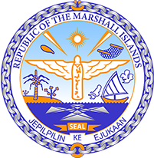

Republic of the Marshall Islands
STATEMENT by H.E. Ambassador Doreen deBrum
43rd Session, Universal Periodic Review
05 May 2023
Geneva
Barbados

Check against delivery

Thank you, Mister President,

The Republic of the Marshall Islands warmly welcomes the Delegation of Barbados and thank them sincerely for the presentation of their report.

We are very pleased to note the 2022 re-election of Barbados’ first female Prime Minister for a second term, as well as the country’s transition to a Parliamentary Republic in 2021. We also commend Barbados’ efforts to combat gender discrimination through the Employment (Prevention of Discrimination) Act of 2020 and the Gender Violence in the Workplace Project, launched in 2021 in conjunction with UN-Women. Nevertheless, gender-based violence and discrimination remain concerning issues.

In the spirit of constructive dialogue, we respectfully recommend the following:

- Enact laws protecting against the withdrawal of pregnant learners from formal education and guaranteeing the re-entry of pregnant learners to schools;
- Amend the Family Law Act to remove any exception to the minimum age of marriage, which is set at 18 years old; and

We wish the delegation every success during its 4th UPR cycle.

Kommol tata and I thank you.

