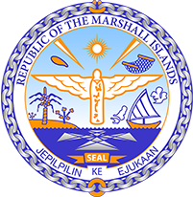

Republic of the Marshall Islands
STATEMENT by Samuel k. Jr, Lanwi
43rd Session, Universal Periodic Review
XX May 2023
Geneva
Bahamas

Check against delivery

Thank you, Mister President,

The Republic of the Marshall Islands warmly welcomes the Delegation of the Bahamas and thanks them for the presentation of their report.

We welcome the Bahamas’ strong commitment to climate action, including the creation of the Climate Change & Environmental Advisory Unit in the Office of the Prime Minister and the passage of the Disaster Risk Management Act in 2022.

We additionally welcome the drafting of various legislation on the promotion and protection of the rights of women and children, including the Strategic Plan to address GBV and the Anti-Gender Based Violence Bill. Nevertheless, we remain concerned by the high prevalence of gender-based violence against women and girls identified by the Committee on the Elimination of Discrimination against Women.

In the spirit of constructive dialogue, we respectfully recommend the following:

- Implement the ICPD25 commitment to achieve zero sexual and gender-based violence by 2030 through the implementation of the “GBV Intervention: Perpetrators” programme; and
- Increase the minimum age of marriage to 18 years old, in compliance with the Convention on the Elimination of All Forms of Discrimination against Women.

We wish the delegation every success during its 4th UPR cycle.

Kommol tata and I thank you.

