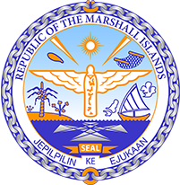

Republic of the Marshall Islands
STATEMENT by H.E. Ambassador Doreen deBrum
43rd Session, Universal Periodic Review
1 May 2023
Geneva
Tonga

Check against delivery

Thank you, Mr President,

The Republic of the Marshall Islands warmly welcomes the delegation of Tonga and thanks them for the presentation of their report.

We commend Tonga’s efforts in implementing their Disaster Recovery Plan for Vulnerable People in the wake of last year’s Hunga Tonga-Hunga Ha’apai volcanic eruption and subsequent tsunami. We are also pleased to note the Government’s development and adoption of the Joint National Action Plan on Climate Change and Disaster Risk Management.

While we are encouraged by Tonga’s focus on protecting vulnerable groups, including women and children, in their disaster recovery policies, we share concerns relating to reports of increased instances of gender-based violence during the pandemic and following the volcanic disaster.

In the spirit of constructive dialogue, we respectfully recommend the following:

- Adopt a holistic, coordinated approach to Gender-Based Violence Prevention and Response that strengthens linkages across ministry mandates and addresses gender-based violence responses during emergency situations;

- Continue efforts to combat corruption and consider adopting a law on financial transparency for elected officials;

- Continue to pursue implementation of Tonga’s Second Nationally Determined Contribution (NDC) under the Paris Climate Agreement, including the commendable goal of achieving 70% renewable energy by 2030.

We wish the delegation every success during its review.

Kommol tata and I thank you.

