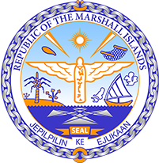

Republic of the Marshall Islands
STATEMENT by Samuel k. Jr, Lanwi
43rd Session, Universal Periodic Review
1 May 2023
Geneva
France

Check against delivery

Thank you, Mr President,

The Republic of the Marshall Islands warmly welcomes the delegation of France to this 4th UPR cycle and thanks them for the presentation of their report.

In the spirit of constructive engagement, we recommend the following:

- Intensify efforts to divest from the fossil fuel sector and strive to set mandatory rules for businesses to report and prevent environmental, climate, and human rights risks;

- Endorse the recommendations made by the Special Rapporteurs made on 11 May 2021 to address the growing concern on police brutality;

- Align its NDCs with the Paris Agreement goal of limiting global warming to 1.5 degrees Celsius above pre-industrial levels; and

- Guarantee access to justice and appropriate remedies to all victims of French nuclear testing, including in North Africa and the South Pacific, and to conduct rigorous and transparent impact assessments of past nuclear testing on human health and the environment.

We wish the delegation every success during its review.

Kommol tata and I thank you.

