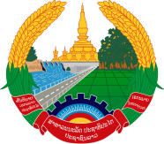
Statement by the delegation of the Permanent Mission of the Lao PDR to the United Nations Office and other International Organizations in Geneva
at the 43rd Session of the UPR Working Group
Geneva, 1-12 May 2023
_________

Review of Luxembourg, 4 May 2023 (14:30-18:00 hours)

Mr. President,
My delegation warmly welcomes and thanks the delegation of Luxembourg for a comprehensive report.

The Lao PDR welcomes the progress made by Luxembourg in fulfilling its reporting obligations under the UN human rights treaty bodies. We commend its strong commitments to the promotion and protection of human rights in the country and to continue its contribution to international development assistance.

My delegation recommends the followings:

- Continue to strengthen international cooperation to promote and protect human rights through the provision of development assistance; and

- Redouble efforts to implement its National Action Plan on the rights of persons with disabilities 2019-2024.

I wish Luxembourg a successful UPR review.

I thank you, Mr. President.

