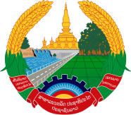
Statement by the delegation of the Permanent Mission of the Lao PDR to the United Nations Office and other International Organizations in Geneva
At the 43rd Session of the UPR Working Group
Geneva, 1-12 May 2023
_________

Review of France, 1 May 2023 (09:00-12:30 hours)

- Mr. President,

- My delegation warmly welcomes and thanks the delegation of the France for a comprehensive presentation of the National Report.

- The Lao PDR commends the progress made by the Government of France in the implementation of the previous UPR recommendations, especially the promotion and protection of the rights of women, children and persons with disabilities.

- My delegation would like to make two recommendations:

- Strengthen the implementation of national measures to ensure gender equality; and

- Continue the ongoing efforts toward advancing fulfilment of the rights of persons with disabilities.

- I wish France every success in its UPR review.

- I thank you, Mr. President.

