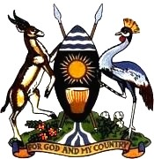
REPUBLIC OF UGANDA

STATEMENT

BY

MARY NAMONO KIBERE OF THE
PERMANENT MISSION OF UGANDA TO THE UNITED NATIONS IN GENEVA

AT THE
THE 4TH UNIVERSAL PERIODIC REVIEW OF ISRAEL

AT

43RD SESSION OF THE UPR WORKING GROUP

MONDAY, 09 MAY 2023

GENEVA

[Please check against delivery]

Thank you, Mr. President,
Uganda warmly welcomes the delegation of Israel and we congratulate the Government of Israel on the presentation of 4th her UPR Report.
We also take this opportunity to commend the Government for the continued cooperation with the Human Rights mechanisms and bodies including all the respective treaty bodies
In the spirit of constructive dialogue, we would like to make recommendations.
- Strengthen the laws and policies to protect all persons from illegal detention.

- Continue to strengthen national mechanisms to ensure equality for all and eliminate all forms of discrimination on grounds of race.

- Strengthen measures to protect the rights of asylum seekers and migrant workers.

We wish our Israeli brothers and sisters successfully review.

Thank you!

