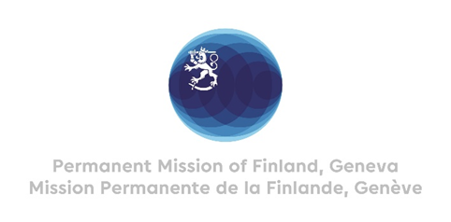

43 Session of the UPR working group Recommendations by Finland to Montenegro

8th May 2023

Mr. President,

Finland congratulates Montenegro for the comprehensive report presented and appreciates the steps taken since the last review.

Finland recommends Montenegro to accept the inquiry procedure under the Optional Protocol to the International Covenant on Economic, Social and Cultural Rights.

Finland wishes Montenegro every success in this fourth UPR-cycle.

I thank you.

