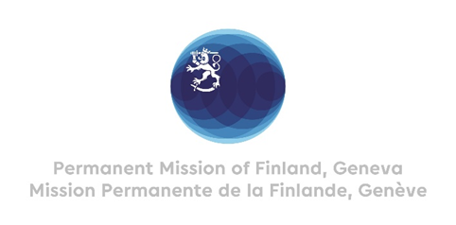

43 Session of the UPR working group Recommendations by Finland to Bahamas

3rd May 2023

Thank you Mr. President,

Finland congratulates Bahamas for the comprehensive report presented.

We commend Bahamas for ratifying the Convention against Torture and Other Cruel Inhuman or Degrading Treatment or Punishment since its last UPR review.

Finland recommends Bahamas:

- First, to consider signing and ratifying the Second Optional Protocol to the International Covenant on Civil and Political Rights aiming to the abolition of the death penalty
- Second, to consider signing and ratifying the Optional Protocol of the Convention against Torture
- Third, to consider establishing a national human rights institution, based on the Paris Principles

We wish Bahamas a successful UPR review.

I thank you.

