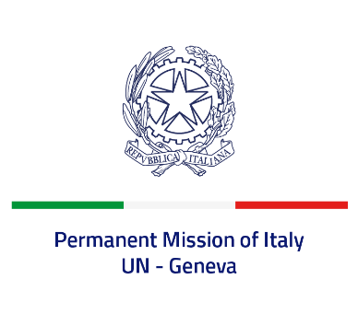
Check against delivery
UPR 43 – Serbia
Wednesday 10 May 2023, 9:00 – 12:30
Delivered by: Permanent Representative of Italy Amb. Vincenzo Grassi

(Focal point: Daniele Borrelli, First Counsellor)

Thank you, Mister President.

We thank the distinguished delegation of Serbia for their national report and presentation.

Italy welcomes Serbia’s efforts to improve the promotion and protection of human rights in the country, including with regard to the fight against discrimination, prevention of domestic violence, rights of persons with disabilities. We also welcome the constitutional reform aimed at strengthening the independence of judiciary.

Italy would like to recommend to:

- Strengthen the implementation of the strategies to prevent and combat all forms of discrimination, including against women and Roma persons.
- Ensure media pluralism and a safe and enabling environment for journalists. Ensure accountability and prosecutions for cases of physical and verbal violence against journalists and media operators.
- Promote freedom of expression, including freedom of speech and information, and ensure that human rights defenders may work safely.

We wish the delegation of Serbia a successful review.

I thank you.

