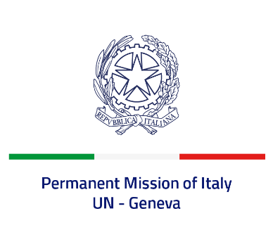
Check against delivery
UPR 43 - Liechtenstein
Tuesday 9 May 2023, 14:30 - 18:00

Delivered by: Ambassador Vincenzo Grassi, Permanent Representative of Italy

(Focal point: Angela Zanca, First Secretary)

Thank you, Mister President.

We thank the distinguished delegation of Liechtenstein for the report and the presentation.

Italy praises Liechtenstein for signing the UN Convention on the Rights of Persons with Disabilities in September 2020 and for the steps taken in order to initiate the necessary legislative amendments with a view to its ratification.

We also welcome the ratification by Liechtenstein of the Council of Europe Convention on Preventing and Combating Violence against Women and Domestic Violence (Istanbul Convention) in June 2021 and commend the recent amendments to the Criminal Code aimed at strengthening protection against gender-based and domestic violence.

Italy seizes this opportunity to offer Liechtenstein the following recommendation:

- Accelerate the ratification process of the Convention on the Rights of Persons with Disabilities.

We wish Liechtenstein a successful review.

I thank you.

