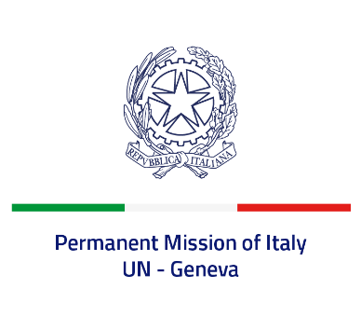
Check against delivery
UPR 43 – Israel
Tuesday 9 May 2023, 9:00 – 12:30
Delivered by: Permanent Representative of Italy Amb. Vincenzo Grassi

(Focal point: Daniele Borrelli, First Counsellor)
Thank you, Mister President.

We thank the distinguished delegation of Israel for their national report and presentation.

Italy welcomes Israel’s commitment to promoting and protecting human rights, in particular with regard to gender equality, elimination of violence against women, rights of persons with disabilities. Italy commends Israel for becoming the first-non European country to accede to the Council of Europe Convention on Action against Trafficking in Human Beings as well as for presenting its first ever resolution at the Human Rights Council on countering cyberbullying.

Italy would like to recommend to:
- Keep on implementing the moratorium on the death penalty for all crimes, and consider ratifying the Second Optional Protocol of the ICCPR on the abolition of the death penalty.
- Strengthen efforts to guarantee freedom of religion or belief, including freedom of worship, and adopt measures to prevent and combat attacks towards holy sites and symbols as well as religiously motivated acts of violence.
- Strengthen efforts to prevent and combat all forms of violence and abuse against children and consider adopting the Safe Schools Declaration.
We wish the delegation of Israel a successful review.
I thank you.

