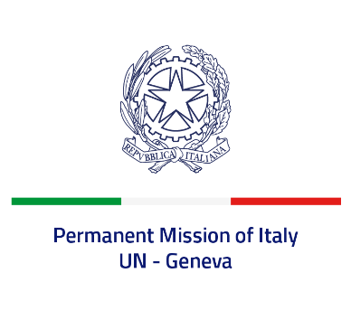
Check against delivery
UPR 43 – United Arab Emirates
Monday 8 May 2023, 14:30 – 18:00
Delivered by: Permanent Representative of Italy Amb. Vincenzo Grassi

(Focal point: Daniele Borrelli, First Counsellor)

Thank you, Mister President.
We thank the distinguished delegation of the United Arab Emirates for their national report and presentation.
Italy welcomes the efforts to enhance human rights protection in the country and the endeavors to promote religious tolerance and interfaith dialogue.
Italy would like to recommend to:

- Adopt a de jure moratorium on capital executions, with a view to fully abolishing the death penalty and consider supporting the UN Resolution for a universal moratorium on capital executions.
- Adopt the First Optional Protocol to the Convention on the Rights of the Child, on the involvement of children in armed conflicts, and endorse the Safe Schools Declaration.
- Sign and ratify the International Covenant on Civil and Political Rights, the International Covenant on Economic, Social and Cultural Rights and other core international human rights conventions.
- Prohibit the practice of secret detention and establish safeguarding measures against forms of torture and ill-treatment, such as inhuman and degrading treatments.
- Strengthen efforts to guarantee freedom of expression and association and devote a greater attention to human rights defenders.
We wish the delegation of the United Arab Emirates a successful review.
I thank you.

