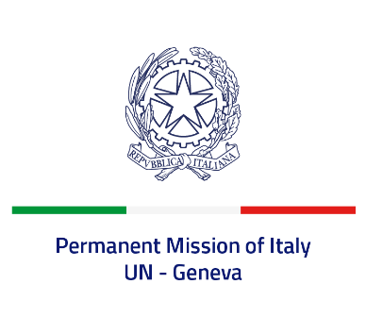
Check against delivery
UPR 43 - Montenegro
Monday 8 May 2023, 9:00 - 12:30

Delivered by: Ambassador Vincenzo Grassi, Permanent Representative of Italy

(Focal point: Angela Zanca, First Secretary)

Thank you, Mister President.

We thank the distinguished delegation of Montenegro for the presentation.

Italy welcomes measures taken by Montenegro to strengthen freedom of expression and media freedom, such us the development of new legislation and the preparation of the first national strategy, as well as to foster the protection of journalists and media workers, through the adoption in 2021 of amendments to the Criminal Code.

Italy seizes this opportunity to offer the following recommendations which are also in line with the European integration process of Montenegro:

- Strengthen efforts to prevent and combat all forms of discrimination and violence against women and girls, and ensure that victims of violence receive appropriate help and assistance and perpetrators are brought to justice.
- Revise legislation to enhance protection against domestic violence, discrimination, hate crimes and hate speech.
- Fully implement the reforms in the judicial sector in order to guarantee the independence and impartiality of the judiciary and eradicate corruption.
- Continue efforts to improve children’s rights and wellbeing, including through strengthening the Council on Child Rights.
- Take measures to ensure that allegations of torture, ill-treatment or excessive use of force by the police are investigated by an independent body and all perpetrators brought to justice.

We wish Montenegro a successful review.

I thank you.

