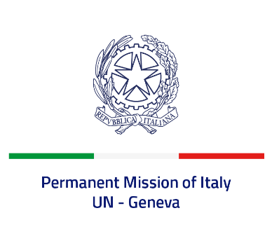
Check against delivery
UPR 43 - Barbados
Friday 5 May 2023, 9:00 - 12:30

Delivered by: Ambassador Vincenzo Grassi, Permanent Representative of Italy

(Focal point: Angela Zanca, First Secretary)

Thank you, Mister President.

We thank the distinguished delegation of Barbados for the report and the presentation.

Italy notes the removal of mandatory death penalty for murder cases through the 2018 Offences Against the Person (Amendment) Act, but is concerned that it remains an option under judicial discretion.

We also recognize current efforts being made by Barbados to strengthen the legislation with regard to child protection and child justice, and look forward to the adoption of the new legislation in order to ensure compliance with the Convention on the Rights of the Child.

Italy seizes this opportunity to offer Barbados the following recommendations:

- Adopt all necessary measures to introduce a de jure moratorium to capital executions with a view to fully abolishing the death penalty.
- Ratify the UN Convention against Torture and Other Cruel, Inhuman or Degrading Treatment or Punishment and ban corporal punishments, especially in schools.
- Continue to strengthen national efforts to combat all forms of gender-based violence and discrimination against women and girls.

We wish Barbados a successful review.

I thank you.

