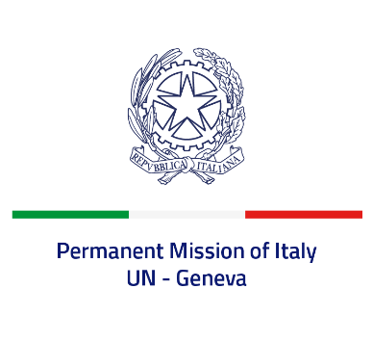
Check against delivery
UPR 43 - Burundi
Thursday 4 May 2023, 9:00 - 12:30

Delivered by: Ambassador Vincenzo Grassi, Permanent Representative of Italy

(Focal point: Angela Zanca, First Secretary)

Thank you, Mister President.

We thank the distinguished delegation of Burundi for the presentation.

Italy welcomes progress on the rule of law, notably the measures taken in order to promote women participation in decision-making process and institutions.

Italy seizes this opportunity to offer Burundi the following recommendations:

- Consider supporting the UN Resolution for a universal moratorium on the use of death penalty and adhering to the Safe School Declaration.
- Reconsider the withdrawal from the International Criminal Court.
- Ensure freedom of expression and association and create a safe and enabling environment for civil society.
- Guarantee the rights of detainees, in line with international standards, prevent and combat torture and implement a fully transparent, equitable and independent judicial system.
- Strengthen the legal framework and judicial services to adequately prevent and respond to sexual and gender-based violence, fight impunity and bring justice to survivors.

We wish Burundi a successful review.

I thank you.

