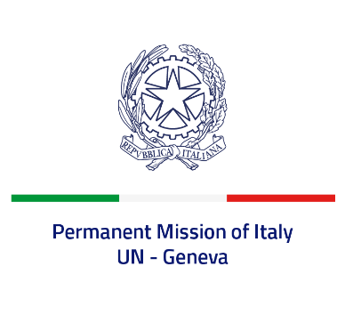
Check against delivery
UPR 43 - Mali
Tuesday 2 May 2023, 14:30 - 18:00

Delivered by: Ambassador Vincenzo Grassi, Permanent Representative of Italy

(Focal point: Angela Zanca, First Secretary)

Thank you, Mister President.

We thank the distinguished delegation of Mali for the report and the presentation.

Italy praises Mali’s support to the UNGA Resolution calling for a moratorium on the use of the death penalty.

Nonetheless, we remain deeply concerned by the worsening security crisis and the deterioration of the human rights and humanitarian situation in the country.

Italy seizes this opportunity to offer Mali the following recommendations:

- Ratify the Second Optional Protocol to the International Covenant on Civil and Political Rights, aiming at the abolition of the death penalty.
- Prevent and combat the recruitment and use of children in armed conflicts, ensure their reintegration in society, and fully implement the Safe Schools Declaration action plan.
- Provide stronger legislative protection of women from violence, end early and forced marriage, and genital mutilation.
- Fight against impunity, ensure that perpetrators of serious human rights violations are prosecuted and that victims have access to justice and reparations.

We wish Mali a successful review.

I thank you.

