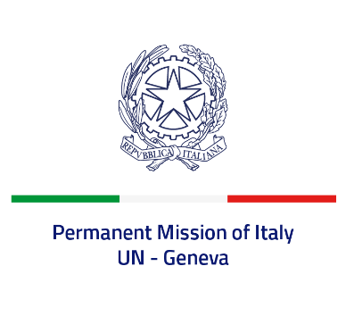
Check against delivery
UPR 43 – Bahamas
Wednesday 3 May 2023, 14:30 – 18:00
Delivered by: Permanent Representative of Italy Amb. Vincenzo Grassi

(Focal point: Daniele Borrelli, First Counsellor)

Thank you, Mister President.

We thank the distinguished delegation of Bahamas for their national report and presentation.

Italy welcomes the ratification of the Convention against Torture and Other Cruel, Inhuman or Degrading Treatment or Punishment.
We also welcome the efforts of Bahamas to strengthen its anti-human trafficking system.

Italy would like to recommend to:

- Consider adopting a de jure moratorium on the use of death penalty and supporting or at least abstaining on the UNGA Resolution for a universal moratorium on the use of death penalty;
- Enhance efforts to prevent and combat all forms of discrimination against women, including domestic and gender-based violence, while reinforcing legal framework on this issue;
- Pursue efforts to guarantee human rights of detainees and improve life conditions in prison.
We wish the delegation of Bahamas a successful review.
I thank you.

