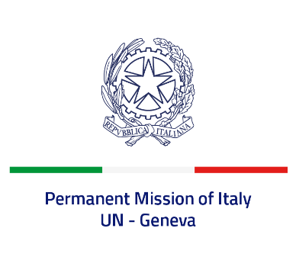
Check against delivery
UPR 43 – Romania
Tuesday 2 May 2023, 9:00 – 12:30
Delivered by: Deputy Permanent Representative of Italy Marie Sol Fulci

(Focal point: Daniele Borrelli, First Counsellor)
Thank you, Mister President.

We thank the distinguished delegation of Romania for their national report and presentation.

Italy commends Romania for its commitment to ensuring the protection and promotion of human rights globally as a current member of the Human Rights Council.
We also welcome the efforts at national level to promote equal opportunities and treatment between women and men as well as to prevent and combat domestic violence.

Italy would like to recommend to:

- Continue to promote the integration of the Roma community, also by implementing the National Strategy launched for the period 2022-2027.
- Continue to fight against human trafficking, by proactively identifying potential victims, increasing the quality and availability of specialized services and training competent officials, ensuring full alignment to international standards.
- Intensify efforts to prevent and combat all forms of discrimination.

We wish the delegation of Romania a successful review.

I thank you.

