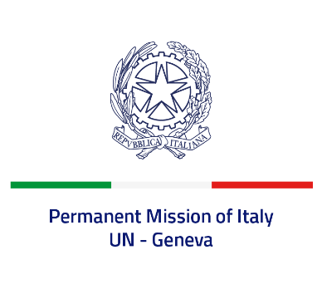
Check against delivery
UPR 43 – Tonga
Monday 1 May 2023, 14:30 – 18:00
Delivered by: Permanent Representative of Italy Amb. Vincenzo Grassi

(Focal point: Daniele Borrelli, First Counsellor)
Thank you, Mister President.

We thank the distinguished delegation of Tonga for their national report and presentation.
Italy welcomes Tonga’s efforts to improve the protection of human rights at national level, including with regard to gender equality and women’s empowerment.
We also welcome the ratification of the UN Convention against Corruption as well as the ratification of the ILO Convention on the Worst Forms of Child Labour.
Italy would like to recommend to:
- Consider introducing a de jure moratorium on capital executions and voting in favor or abstaining on the UN Resolution for a moratorium on the use of death penalty
- Take steps to protect children’s rights and consider adhering to the Safe School Declaration. End child marriage by raising to 18 the minimum age of marriage for both boys and girls
- Ratify the Convention on the Elimination of All Forms of Discrimination against Women and strengthen national measures to prevent and combat all forms of discrimination and violence against women, including domestic violence
- Strengthen efforts to ratify the Convention on the Rights of Persons with Disabilities
We wish the delegation of Tonga a successful review. I thank you.

