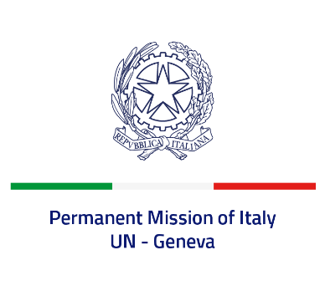
Check against delivery
UPR 43 - France
Monday 1 May 2023, 9:00 - 12:30

Delivered by: Ambassador Vincenzo Grassi, Permanent Representative of Italy

(Focal point: Angela Zanca, First Secretary)

Thank you, Mister President.

We thank the distinguished delegation of France for the presentation.

Italy commends France for its ongoing commitment to ensuring the protection and promotion of human rights and fundamental freedoms globally, as a current member of the Human Rights Council.

We particularly praise the steps taken at both national and international levels to promote the rights of women and girls, to fight all forms of discrimination against them, as well as to ensure gender equality.

Italy seizes this opportunity to offer France the following recommendation:

- Continue efforts to prevent and combat all forms of discrimination, including racial discrimination and Antisemitism through the implementation of the newly adopted National Plan against racism, Antisemitism and discrimination related to origin.

We wish France a successful review.

I thank you.

