Please check against delivery: One (01) minute
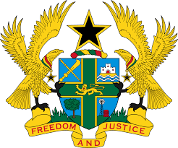

STATEMENT BY GHANA DELIVERED BY AKOSUA D. OKYERE BADOO,
CHARGÉ D'AFFAIRES/ DEPUTY PERMANENT REPRESENTATIVE, MONDAY, 8TH MAY, 2023

REVIEW OF UNITED ARAB EMIRATES
Thank you, Mr. President.

Ghana warmly welcomes the delegation of United Arab Emirates (UAE) to the UPR Working Group.
2. My delegation commends the UAE for its commitment in improving its human rights record, especially, through cohesive national policies like the Vision 2021, the national strategy for women’s empowerment, the policy for older persons, and the strategy for higher education.
3. We further acknowledge the National Human Rights Committee in October 2019 and the National Human Rights Institution in 2021.
4. In the spirit of constructive dialogue Ghana makes the following recommendations to UAE:
- Continue efforts to ratify outstanding core Human Rights treaties, particularly the OP-CAT and Optional Protocol to the Convention on the Elimination of All Forms of Discrimination against Women; and
ii. Continue to take further steps to improve participation and engagement of women in political work and legislative processes of the country.
5. Ghana wishes United Arab Emirates a successful review outcome.

I thank you.

