Please check against delivery: One (01) minute twenty (20) seconds
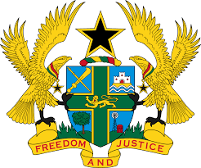

STATEMENT BY GHANA DELIVERED BY AKOSUA D. OKYERE BADOO,
CHARGÉ D'AFFAIRES/ DEPUTY PERMANENT REPRESENTATIVE,
TUESDAY, 9TH MAY, 2023
REVIEW OF ISRAEL

Thank you, Mr. President.

Ghana warmly welcomes the delegation of Israel to the UPR Working Group and thanks them for the presentation of their report.
2. My delegation welcomes the commitment by the Government in ensuring the protection of human rights in the country, including efforts made to provide equitable healthcare services for all, without prejudice, promote gender parity in the public arena, eradicate violence against women and girls, and combat racial discrimination.

3. We further acknowledge the progress made in protecting children's rights and their welfare in the country through the adoption of various strategies such as the establishment of the two new institutions on the rights of children and youth.
4. To further enhance Israel’s commitment to the protection of Human Rights, Ghana recommends that Israel:
- Continue to reinforce relevant measures to promote and protect the rights to freedom of expression and rights to peaceful assembly;
- Continue to take further steps to ensure full respect for the right to freedom of religion or belief, in accordance with international human rights obligations.; and
- Take active measures to combat racism and hate speech against asylum-seekers of African descent.
5. Ghana wishes Israel a successful review outcome.

I thank you.

