Check against delivery: One (1) Minute and Thirty(30)

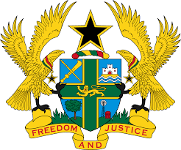

STATEMENT BY GHANA DELIVERED BY AKOSUA D. OKYERE BADOO,
CHARGÉ D'AFFAIRES/ DEPUTY PERMANENT REPRESENTATIVE,
FRIDAY, 5TH MAY, 2023

REVIEW OF BARBADOS

Thank you, Mr. President.

Ghana warmly welcomes the delegation of Barbados to the UPR Working Group.
2. My delegation acknowledges the Government of Barbados' commitment to safeguarding and advancing the human rights of all. We take note of the significant strides made by the Constitutional Review Commission in overseeing the development and implementation of a new Constitution of Barbados. Additionally, we commend Barbados for its heightened efforts to combat corruption, exemplified by the adoption of the Prevention of Corruption Bill in 2021.
3. The establishment of the National Committee on Gender-based Violence in 2019, in charge of the development of a national action plan against gender-based violence is commendable. We also applaud the Government for its continued effort to combat violence against children particularly through the provision of additional financial and human resources to the Child Care Board.
4. Ghana makes the following recommendations to Barbados;
- Continue efforts to ratify outstanding core Human Rights treaties, of note is OP-CAT and International Convention on the Protection of the Rights of All Migrant Workers; and
- Intensify efforts for bringing domestic legislation on combating all forms of discrimination in line with international standards.
We wish Barbados a successful review outcome.
I thank you.

