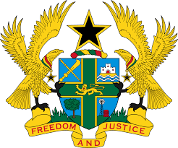

STATEMENT BY GHANA DELIVERED BY AKOSUA D. OKYERE BADOO,
CHARGÉ D'AFFAIRES/ DEPUTY PERMANENT REPRESENTATIVE,
THURSDAY, 4TH MAY, 2023

REVIEW OF BURUNDI

Thank you, Mr. President.
Ghana warmly welcomes the delegation of Burundi to the UPR Working Group.
2. The government's adoption of laws to strengthen human rights, including the acts on the rights of persons with disabilities and the truth and reconciliation commission, is highly commendable.
3. We also acknowledge the establishment of the National Gender Commission and the national preventive mechanism on Torture and urge the Government to allocate adequate resources for their implementation.
4. To further strengthen the protection and promotion of human rights in Burundi, Ghana recommends that Burundi;
- Continue efforts to combat gender-based violence against women and promote gender equality;
- Adopt effective measures to end intimidation and harassment of journalists;
- Continue awareness-raising campaigns on women’s leadership and adopt reforms to promote women’s participation in decision- making bodies; and
- Accelerate efforts to improve health services, especially in rural areas through the effective implementation of the National Health.
We wish Burundi a successful review outcome.
I thank you.

