Check against delivery: One (1) Minute and Five (5)

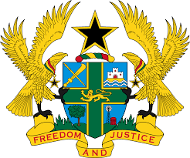

STATEMENT BY GHANA DELIVERED BY AKOSUA D. OKYERE BADOO,
CHARGÉ D'AFFAIRES/ DEPUTY PERMANENT REPRESENTATIVE,
WEDNESDAY, 3RD MAY, 2023

REVIEW OF BOTSWANA

Thank you, Mr. President.
Ghana warmly welcomes the delegation of Botswana to the UPR Working Group and thanks them for their report.
2. My delegation applaud the significant progress made in implementing previous recommendations to promote and protect human rights, including the establishment of the Ministry of Justice in April 2022 and completion of the Comprehensive Human Rights Strategy and National Action Plan (CHRSNAP) draft in December 2021. We also acknowledge the new school feeding program.
3. To further enhance Botswana’s commitment to the protection of Human Rights, Ghana recommends that Botswana:
- Consider ratifying outstanding core international legal instruments; notably OP-CAT;
- Provide regular training to law enforcement officials and other stakeholders within the field of human rights, in particular in the documentation and investigation of cases related to torture and ill-treatment;
- Revise national legislation that might restrict the right to freedom of expression; and
- Establish a national accountability mechanism to combat sexual and gender-based violence and advance gender equality.
We wish Botswana a successful review outcome.
I thank you.

