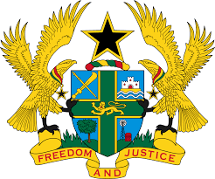
STATEMENT BY GHANA DELIVERED BY AKOSUA D. OKYERE BADOO,
CHARGÉ D'AFFAIRES/ DEPUTY PERMANENT REPRESENTATIVE,
TUESDAY, 2ND MAY, 2023

REVIEW OF MALI

Thank you, Mr. President.
Ghana warmly welcomes the delegation of Mali to the UPR Working Group and thanks them for their report.
2. The efforts at aligning national legislation with human rights standards such as the adoption of Act No.2018-027 in 2018 on the rights of persons living with a disability and the ratification of the Protocol to the African Charter on Human and Peoples’ Rights on the Rights of Older Persons in Africa is highly commendable.
3. We also acknowledge the efforts made by the Government in implementing the Agreement on Peace and Reconciliation in Mali.
4. To further strengthen human rights promotion and protection in Mali Ghana wishes to make the following recommendations:
- Strengthen implementation of legislation and policies aimed at ending harmful traditional practices in particular child marriage and female genital mutilation;
- Take appropriate and effective measures to prevent, investigate and punish acts of violence against women, in particular sexual violence; and
- Ensure full respect for the right to freedom of expression by removing all
obstacles and ensuring media freedom.
We wish Mali a successful review outcome.

I thank you.

