Please check against delivery: fifty-five (55) seconds
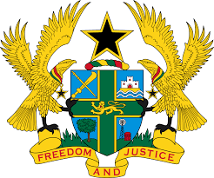

STATEMENT BY GHANA DELIVERED BY AKOSUA D. OKYERE BADOO,
CHARGÉ D'AFFAIRES/ DEPUTY PERMANENT REPRESENTATIVE, MONDAY, 1ST MAY, 2023

REVIEW OF FRANCE

Thank you, Mr. President.

Ghana warmly welcomes the delegation of France to the UPR Working Group.
2. My delegation commends the government for the commitment and considerable progress in promoting, protecting and respecting human rights in the country since its last UPR and welcomes the adoption of the National Housing Strategy (the Five-year Plan for Housing First) and the Fight against Homelessness (2018 – 2022).
3. We further acknowledge the adoption of recent laws to strengthen the fight against racism and discrimination, including the law to combat hateful content on the Internet.
4. In the spirit of constructive dialogue Ghana makes the following recommendations to France:
i. To redouble its efforts in enforcing legislation and bringing perpetrators of racial discrimination, racist hate speech and xenophobia to justice.
ii. To provide adequate and specialized training to law enforcement agencies in order to address reports of increased cases of abusive and violent behaviour directed at ethnic and religious minorities.
5. Ghana wishes France a successful review outcome.

I thank you.

