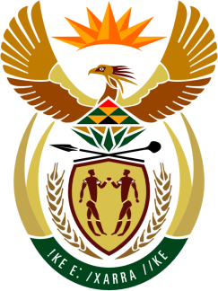

SOUTH AFRICAN PERMANENT MISSION
TO THE UNITED NATIONS
AND OTHER INTERNATIONAL ORGANISATIONS

43rd SESSION OF THE WORKING GROUP ON THE
UNIVERSAL PERIODIC REVIEW

Review of barbados

05 MAY 2023

(1 MINUTE 25 Seconds)

speaker no: 19

Check against delivery.

Mr. President,

South Africa welcomes the distinguished delegation of Barbados to this UPR Session and wishes the country a successful review.
South Africa welcomes the ratification in September 2022 of the International Labour Organisation (ILO) Convention 190 – Violence and Harassment in the World of Work, 2019 and the Accession to the Marrakesh Treaty to Facilitate Access to Published Works for Persons Who Are Blind on 20 February 2023. South Africa further welcomes that Barbados became a signatory to the UN Treaty on the Prohibition of Nuclear Weapons in September 2022.
South Africa wishes to make the following recommendations:
- Enact appropriate legislation to guarantee the principle of equal pay for work of equal value in all areas of work, intensifying efforts to create an enabling environment for women to become economically independent and ensuring that women doing unpaid work were eligible for retirement and other work-related benefits.

- Develop appropriate legislation to prevent discrimination against Persons with Disabilities

- Repeal laws that criminalise consensual same-sex sexual relations and further recommend that the proposed “Charter of Barbados” included protection against discrimination on the grounds of gender and sexual orientation.

I thank you.

