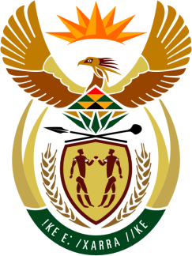

SOUTH AFRICAN PERMANENT MISSION
TO THE UNITED NATIONS
AND OTHER INTERNATIONAL ORGANISATIONS

43rd SESSION OF THE WORKING GROUP ON THE
UNIVERSAL PERIODIC REVIEW

Review of ROMANIA

02 MAY 2023

09:00-12:30

(1 minute 25 Seconds)

speaker no: 6

Check against delivery

Mr. President,

South Africa welcomes the distinguished delegation of Romania to this UPR Session and wishes the country a successful review.

South Africa commends Romania for its commitment to fight corruption, including through the adoption of its 6th National Anti- corruption Strategy (NAS) for the period 2021-2025.

In order to ensure progress in promoting and protecting human rights, South Africa wishes to respectively recommend that Romania:

- Bolster efforts to prevent the trafficking of persons including through the training of authorities to deal with human trafficking cases in a victim-sensitive and trauma-sensitive manner.

- Ensure full access to sexual and reproductive health services including age-appropriate educational programmes in schools on sexual and reproductive health.

- Enhance measures to prevent discrimination against all vulnerable groups, including women, children and persons living with HIV/AIDS, person from the LGBTI+ community, the Roma and other ethnic and racial minorities.

- Continue efforts towards inclusive education, especially for students living in rural areas, students from minorities and students with disabilities.

I thank you

