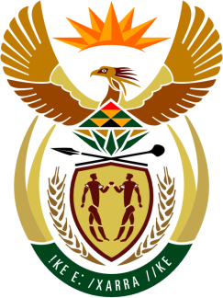

SOUTH AFRICAN PERMANENT MISSION
TO THE UNITED NATIONS
AND OTHER INTERNATIONAL ORGANISATIONS

43rd SESSION OF THE WORKING GROUP ON THE
UNIVERSAL PERIODIC REVIEW

Review of ISRAEL

09 MAY 2023
(09:00-12:00)

80 Seconds

speaker no: 29

Check against delivery

Mr. President,

South Africa welcomes the distinguished delegation of Israel to this UPR Session and wishes the country a successful review.

South Africa wishes to recommend that Israel:

- Take the necessary legislative, administrative and other measures to ban conversion practices for LGBTI+ communities, in specific, adopt, as soon as possible, a Welfare Ministry Directive prohibiting social workers from engaging in conversion practices; make further effort to pass a bill outlawing conversion practices within four years.

- Repeal all legislation enshrining racial discrimination, domination, and oppression, including in the domains of citizenship and land, including Israel’s Basic Law: Israel – National State of the Jewish People of 2018 (the Nation State Law) which it uses to justify the oppression and discrimination of Palestinians by Israel.

- As a state party to the International Convention on the Elimination of All Forms of Racial Discrimination, give full effect to article 3 of the Convention which stipulates that State Parties “particularly condemn racial segregation and apartheid and undertake to prevent, prohibit and eradicate all practices of this nature in territories under their jurisdiction” on both sides of the Green Line and in line with the recommendations by the Committee on the Elimination of Racial Discrimination.

- Put an end to the silencing and delegitimisation campaigns targeting Palestinian civil society and human rights defenders who play a vital role in exposing violations and advancing Palestinian self-determination as well as protecting the right to legitimate resistance against Israeli domination.

I thank you.

