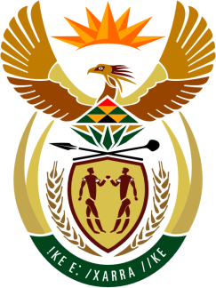

SOUTH AFRICAN PERMANENT MISSION
TO THE UNITED NATIONS
AND OTHER INTERNATIONAL ORGANISATIONS

43rd SESSION OF THE WORKING GROUP ON THE
UNIVERSAL PERIODIC REVIEW

Review of BURUNDI

04 MAY 2023
(09:00-12:30)

70 Seconds

speaker no: 63

Check against delivery

Mr. President,

South Africa welcomes the distinguished delegation of Burundi to this UPR Session.

My delegation is encouraged by Burundi’s commitment to promoting and protecting human rights which is reflected through, among others, the renewal of the mandates of the Office of the Ombudsman and the Truth and Reconciliation Commission, as well as the establishment of a department for the prevention of gender-based violence and the creation of a national committee for persons with disabilities.

South Africa wishes to respectfully recommend that Burundi:

- Continue efforts to ensure the independence of the National Independent Human Rights Commission.

- Enhance reforms to promote and protect the right to work and the right to just and favourable conditions of work for women, persons living with disabilities, and other vulnerable groups.

- Strengthen measures towards removing structural and legal barriers to women’s participation in politics and decision-making processes.

South Africa wishes Burundi a successful review.

I thank you

