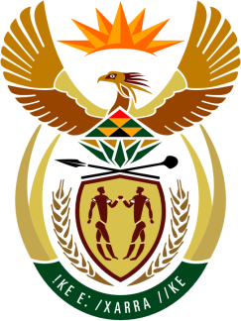

SOUTH AFRICAN PERMANENT MISSION
TO THE UNITED NATIONS
AND OTHER INTERNATIONAL ORGANISATIONS

43rd SESSION OF THE WORKING GROUP ON THE
UNIVERSAL PERIODIC REVIEW

Review of THE BAHAMAS

03 MAY 2023

(1 MINUTE 25 Seconds)

speaker no: 21

Check against delivery

Mr. President,

South Africa welcomes the distinguished delegation of The Bahamas to this UPR Session and wishes the country a successful review.
South Africa the inter alia acknowledges the efforts of The Bahamas to bolster the fight against crime and gender-based violence and welcomes the ratification of the Convention against Torture and Other Cruel Inhuman or Degrading Treatment or Punishment.
South Africa wishes to make the following recommendations:
- Strengthen constitutional provisions and national legislation to ensure that the principle of equality between women and men and the prohibition of sex-based discrimination were enshrined in national legislation.

- Enact appropriate legislation to guarantee the principle of equal pay for work of equal value in all areas of work, intensifying efforts to create an enabling environment for women to become economically independent and ensuring that women doing unpaid work were eligible for retirement and other work-related benefits.

- Enact appropriate legislation to effectively address the high reported incidence of hate crimes against the LGBTI+ communities.

- Consider setting targets for political parties, to ensure increased participation of women in political and public life.

I thank you.

