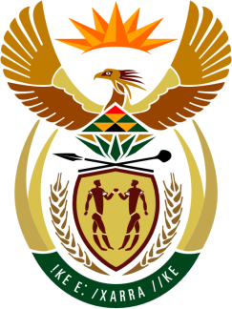

SOUTH AFRICAN PERMANENT MISSION
TO THE UNITED NATIONS
AND OTHER INTERNATIONAL ORGANISATIONS

43rd SESSION OF THE WORKING GROUP ON THE
UNIVERSAL PERIODIC REVIEW

Review of MALI

02 MAY 2023
(14:30-18:00)

70 Seconds

speaker no: 29

Check against delivery

Mr. President,

South Africa welcomes the distinguished delegation of Mali to this UPR Session and wishes the country a successful review.

South Africa acknowledges recent initiatives in Mali such as the adoption of the new National Plan of Action for the Elimination of Child Labour for the period 2023–2027, the Ten-Year Development Plan for the Empowerment of Women, Children and Families for 2020–2029, and the national multisectoral strategy to end child marriage which was adopted in 2022.

South Africa wishes to respectfully recommend that Mali:

- Continue efforts to restore constitutional order.

- Provide adequate financial resources to the National Human Rights Commission to support its functioning.

- Enhance measures to combat sexual and gender-based violence including passing, into law, the draft bill on gender-based violence.

- Expedite the revision of the draft child protection law, as well as adopting and implementing the draft law on the protection of educational institutions from attacks.

I thank you

