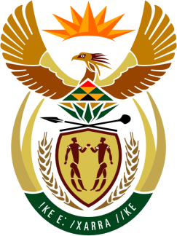

SOUTH AFRICAN PERMANENT MISSION
TO THE UNITED NATIONS
AND OTHER INTERNATIONAL ORGANISATIONS

43rd SESSION OF THE WORKING GROUP ON THE
UNIVERSAL PERIODIC REVIEW

Review of BOTSWANA

03 MAY 2023

(65 Seconds)

speaker no: 85

Check against delivery

Mr. President,

South Africa welcomes the distinguished delegation of the fraternal Republic of Botswana to this UPR Session and wishes the country a successful review.

We commend Botswana for the strides made in advancing the promotion and protection of human rights. In particular, we welcome the range of initiatives undertaken, including the establishment of the National Gender Commission, the development of the Comprehensive Human Rights Strategy and National Action Plan, as well as the transformation of the Office of the Ombudsman. We similarly wish to acknowledge the recommendations arising from the Constitutional Review process concerning the protection of the rights to health, land, education and work.

South Africa wishes to make the following recommendations:

- Ratify the International Covenant on Economic, Social and Cultural Rights and the Optional Protocol;
- Bolster the legal and institutional frameworks to protect women against violence and ensure the full and effective implementation of the Domestic Violence Act; and
- Introduce special measures to increase the number of women in decision-making positions.

I thank you (Ke a leboga)

