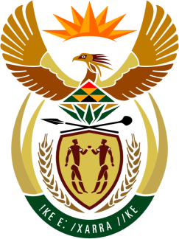

SOUTH AFRICAN PERMANENT MISSION
TO THE UNITED NATIONS
AND OTHER INTERNATIONAL ORGANISATIONS

43rd SESSION OF THE WORKING GROUP ON THE
UNIVERSAL PERIODIC REVIEW

Review of FRANCE

01 MAY 2023

(55 Seconds)

speaker no: 12

Check against delivery

Mr. President,

South Africa welcomes the distinguished delegation of France to this UPR Session and wishes the country a successful review.

South Africa acknowledges France’s efforts to bolster the fight against racism. This includes those activities undertaken to augment legislation, together with the implementation of national plans and large-scale surveys in this regard.

South Africa wishes to make the following recommendations:
- Strengthen initiatives to address the structural and systemic causes of racial discrimination against minorities, including people of African descent;
- Take measures to ensure impartial investigations by bodies external to the police into all cases of racist incidents involving police officers;
- Increase efforts to ensure that Mahorais enjoy their economic, social and cultural rights fully and on an equal basis with the rest of France’s population; and
- Review the relevant laws concerned with rape and attempted rape to incorporate the concept of non-consent.

I thank you

