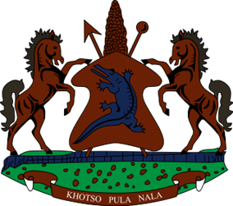

STATEMENT BY THE KINGDOM OF LESOTHO DURING THE 4TH UPR REVIEW OF MALI

02 MAY 2023

Thank you, Mr. President,
Lesotho welcomes the distinguished delegation of Mali to the working Group and thanks them for the presentation of their Report. My delegation is cognizant of the measures put in place by Mali to promote and protect human rights of its citizens. Lesotho applauds the government of Mali for its efforts to align national legislation with human rights standards, through the revision of the Criminal Code and the Code of Criminal Procedure. We welcome efforts made to combat torture by providing continuous training to criminal investigation officers, prison officers and supervised education officer.
Despite the progress made, Lesotho is aware of the challenges that Mali has been grappling with, in respect to the fulfillment of the human rights of its people and therefore in a constructive spirit, Lesotho recommends that: 1. Mali to continue efforts to prohibit all forms of violence against children in all settings, including recruitment of children as child soldiers and corporal punishment. 2. To redouble efforts to train and capacitate defence and security forces on the excessive use of force and 3. To bolster efforts to investigate acts of violence against women and girls, including domestic violence.
Finally, we wish Mali every success with this implementation of the recommendations emanating from this UPR cycle.

