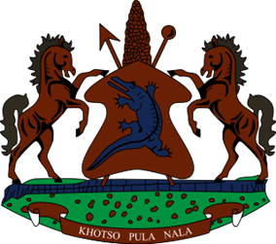

STATEMENT BY THE KINGDOM OF LESOTHO DURING THE 4TH UPR REVIEW OF BOTSWANA

03 MAY, 2023

Thank you, Mr. President,

Lesotho welcomes the distinguished delegation of Botswana to the 4th UPR cycle, and thanks them for their comprehensive Report and presentation. We commend them for the positive developments achieved since their last review, notably in strengthening programmes to address economic and social challenges, including through the adoption of programmes aimed at improving employment and wealth creation. We specifically welcome the efforts to strengthen public sector by introducing Results Based Monitoring and Evaluation (M&E) System within the Directorate on Corruption and Economic Crime (DCEC).
In spite of the positive developments noted, Lesotho wishes to make the following constructive recommendations for consideration by Botswana: 1. To continue efforts to ensure that perpetrators of sexual violence against women and girls are punished. 2. To bolster efforts to ensure the enjoyment of sexual and reproductive health rights of adolescents in Botswana, particularly on access to contraceptives. 3. To Undertake efforts to accede to the Covenant on Economic, Social and Cultural Rights.
Lesotho wishes Botswana every success with the implementation of the recommendations emanating from this review.
I thank you

