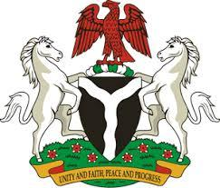

Please check against delivery

HUMAN RIGHTS COUNCIL
43RD SESSION OF THE UPR WORKING GROUP
STATEMENT
BY THE
FEDERAL REPUBLIC OF NIGERIA
ON THE
REVIEW OF THE UNITED ARAB EMIRATES
8TH MAY, 2023

Mr. President,
Nigeria warmly welcomes the Emirati delegation to the presentation of its National Report and commends the Government for its unwavering commitment to its international human rights obligations and continued cooperation with human rights mechanisms.
2. We commend the strident efforts of the Emirati Government in enacting national legislation that promotes and guarantees enjoyment of human rights. Specifically, my Delegation takes positive note of the national legislation affecting women adopted by the United Arab Emirates, as well as the national strategy for the empowerment and advancement of women. Nigeria further welcomes the adoption of the national family policy and the family protection policy of the UAE.
3. In the spirit of constructive dialogue, Nigeria wishes to recommend the following for consideration by the Emirati Government:
- to continue strengthening the initiative of the National Committee to Combat Human Trafficking, in tackling sex trafficking;
- to adopt positive measures to eliminate discrimination against persons belonging to religious minorities; and
- to consider taking further necessary measures to ensure adequate protection of the rights of migrants.
4. In conclusion, we wish the United Arab Emirates a very successful review process.
I thank you Mr. President.

