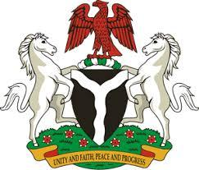

Please check against delivery

HUMAN RIGHTS COUNCIL
43RD SESSION OF THE UPR WORKING GROUP
STATEMENT
BY THE
FEDERAL REPUBLIC OF NIGERIA
ON THE
REVIEW OF ISRAEL
9TH MAY, 2023

Mr. President,
Nigeria warmly welcomes the delegation of Israel to the presentation of its National Report and commends the Government for its unwavering commitment to its international human rights obligations and continued cooperation with human rights mechanisms.
2. Nigeria takes positive note of the concerted efforts of the Government of Israel in advancing equality in women’s representation in the Civil Service, high-ranking and decision-making positions in Israel. We commend the Israeli Government for introducing the Child Online Protection Bureau to prevent violence and crimes against children and teenagers online. My delegation finds it curious that the Israeli Government steadfastly protects the rights of its citizens to live freely, regardless of their sexual orientation, yet prohibits polygamy.
3. In the spirit of constructive dialogue, Nigeria wishes to recommend the following for consideration by the Israeli Government:
- to guarantee full respect for the right to freedom of religion or belief, in law and practice, without discrimination, in accordance with international human rights obligation;
- to ensure the effective protection of persons belonging to religious minorities from all forms of violence and harassment; and
- to repeal the prohibition of polygamy.
4. In conclusion, we wish Israel a very successful review process.

I thank you Mr. President.

