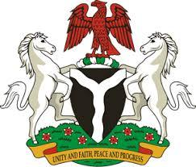
Please check against delivery
HUMAN RIGHTS COUNCIL
43RD SESSION OF THE WORKING GROUP OF THE UPR REVIEW OF THE REPUBLIC OF BARBADOS
5TH MAY, 2023
STATEMENT BY NIGERIA
Mr. President,
Nigeria warmly welcomes the delegation of the brotherly Republic of Barbados to the presentation of its National Report and commends the efforts of the Government on the implementation of previous recommendations, as well as its continuous cooperation with Human Rights mechanism.
2. Nigeria takes positive note of the inclusion of more women in high-ranking and decision-making positions in Barbados. We laud the establishment of a Constitutional Review Commission (CRC) to oversee the development and enactment of a new Constitution for Barbados. My Delegation further welcomes the ratification of the International Labour Organisation (ILO) Convention 190 on Violence and Harassment in the World of Work by the Government of Barbados.
3. While acknowledging these spirited efforts by Barbados and cognizant of the need for improvement, Nigeria wishes to recommend the following, in the spirit of constructive engagement:
- to complete the process of establishing a National Human Rights Institution, in accordance with the Paris Principle; and
- to eliminate gender-pay gap, by ensuring parity in wages paid to men and women performing the same functions in same organization.
4. In conclusion, we wish Barbados every success in its review.
I thank you.
******

