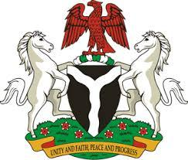
Please check against delivery
HUMAN RIGHTS COUNCIL
43RD SESSION OF THE WORKING GROUP OF THE UPR REVIEW OF THE REPUBLIC OF BURUNDI
4TH MAY, 2023
STATEMENT BY NIGERIA
Mr. President,
Nigeria warmly welcomes the delegation of the brotherly Republic of Burundi to the presentation of its National Report and commends the efforts of the Government towards the implementation of previous recommendations, as well as its continuous cooperation with Human Rights mechanisms.
2. My Delegation takes positive note of the renewal of the mandate of the Office of the Ombudsman and the Truth and Reconciliation Commission. We further welcome the significant progress the Republic of Burundi has made in the administration of juvenile justice. In addition, the adoption of an inclusive education policy remains noteworthy.
3. While acknowledging these spirited efforts by Burundi and cognizant of the need for improvement, Nigeria wishes to recommend the following, in the spirit of constructive engagement:
- to ratify the Convention against Discrimination in Education;
- to ratify the International Convention on the Protection of the Rights of All Migrant Workers and Members of their Families;
4. In conclusion, we wish Burundi every success in its review.
I thank you.
******

